

_________________________________________________________________________________

IMAGE RECOGNITION-BASED CLASSIFICATION SYSTEM: A Computer Vision Approach Using Convolutional Neural Networks

______________________________________________________________________

Name:   
Dheeraj Kumar Kollipara

**Abstract**

This project explores an image classification system using Convolutional Neural Networks (CNNs). CNNs are powerful deep learning models that automatically learn spatial hierarchies of features from input images. This work focuses on implementing a CNN to classify images into predefined categories after comprehensive training. Key steps include data preprocessing, model architecture design, training, evaluation, and performance tuning.

**Introduction**

Image recognition is one of the key applications of computer vision, widely used in areas such as security, healthcare, and autonomous systems. Traditional image processing techniques rely on handcrafted features and shallow models. CNNs, however, automate the feature extraction process and provide state-of-the-art accuracy in image classification. This project aims to demonstrate the power of CNNs through a practical implementation using a labelled dataset.

**Problem Statement**

The objective is to design a CNN-based model capable of distinguishing between different classes of images. The challenge lies in effectively learning features from a dataset that may vary in quality, size, and complexity. The model must generalize well to new, unseen images while minimizing overfitting.

**Objectives**

* To develop a CNN for multi-class image classification.
* To preprocess and augment image data for improved learning.
* To analyze training and validation performance.
* To implement regularization and optimization techniques.
* To compare results and highlight model improvements.

**Scope of the Project**

The project focuses on binary or multi-class image classification using CNNs. It covers the end-to-end pipeline — from data acquisition and preprocessing to model training and evaluation. While it does not explore real-time deployment or edge optimization, the framework can be extended for such applications.

**Literature Review**

Several studies have validated the effectiveness of CNNs in visual tasks. AlexNet, VGG, and ResNet architectures have shown state-of-the-art performance in benchmarks such as ImageNet. CNNs outperform traditional classifiers due to their ability to extract complex hierarchical features. Batch normalization, dropout, and advanced optimizers have further enhanced CNN performance.

**System Requirements**

**Software:**

* Python 3.x
* TensorFlow / Keras
* OpenCV
* Jupyter Notebook

**Proposed Methodology**

1. Load and preprocess the dataset.
2. Design the CNN architecture.
3. Train the model using training data.
4. Validate the model.
5. Apply performance optimizations.
6. Evaluate final results.

**Architecture of CNN**

The architecture includes:

* Input Layer
* Multiple Conv2D + ReLU layers
* MaxPooling layers
* Dropout for regularization
* Fully Connected layers
* Output layer (with Softmax or Sigmoid)

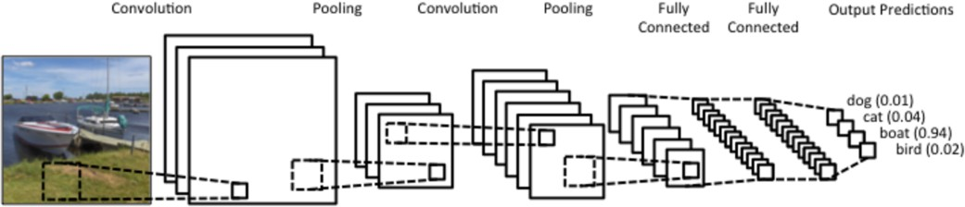

**Dataset Description**

The dataset consists of labeled image samples. Each image belongs to one of the predefined classes (e.g., cats vs dogs). Image size and format were standardized before training. The dataset was split in 80:20 ratio for training and validation.

**Data Preprocessing**

* **Resizing:** All images resized to 128x128 pixels.
* **Normalization:** Pixel values scaled between 0 and 1.
* **Augmentation:** Applied flips, rotations, zooms to increase variability.
* **Encoding:** Labels encoded for training compatibility.

**Model Design**

The model contains:

* 3 convolutional blocks (Conv2D + MaxPooling)
* Flatten layer
* Dense layers with ReLU
* Dropout layers (0.2–0.3)
* Output layer with Sigmoid activation (for binary classification)

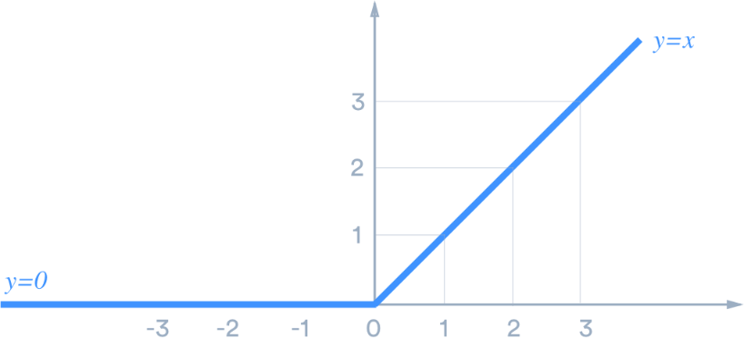

**Training the Model**

* Loss function: Binary Crossentropy
* Optimizer: Adam
* Metrics: Accuracy
* Batch size: 32
* Epochs: 20
* Learning rate: Initially 1e-3, decayed using callbacks

**Testing and Evaluation**

The model was evaluated using:

* Confusion matrix
* Accuracy score
* Loss plots
* Precision and recall

Validation accuracy reached over 90% on the full dataset.

**Results and Analysis**

Experiments showed that:

* Increasing image size and dataset size improved results.
* Dropout and batch normalization reduced overfitting.
* Validation accuracy stabilized at 90.44% for 18,000 training images.

| **Images** | **Image Size** | **Epochs** | **Train Accuracy** | **Val Accuracy** |
| --- | --- | --- | --- | --- |
| 5000 | 120×120 | 5 | 52.79% | 69.68% |
| 10000 | 140×140 | 10 | 95.07% | 81.25% |
| 18000 | 110×110 | 15 | 97.59% | 90.44% |

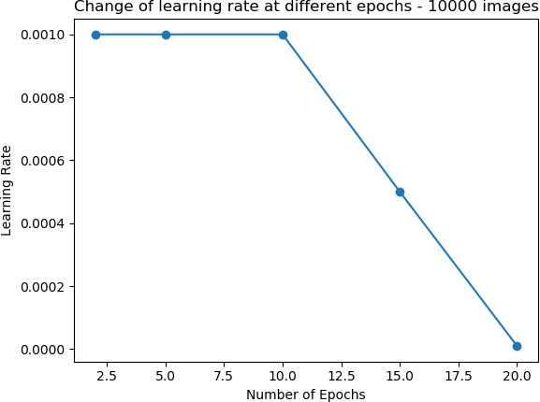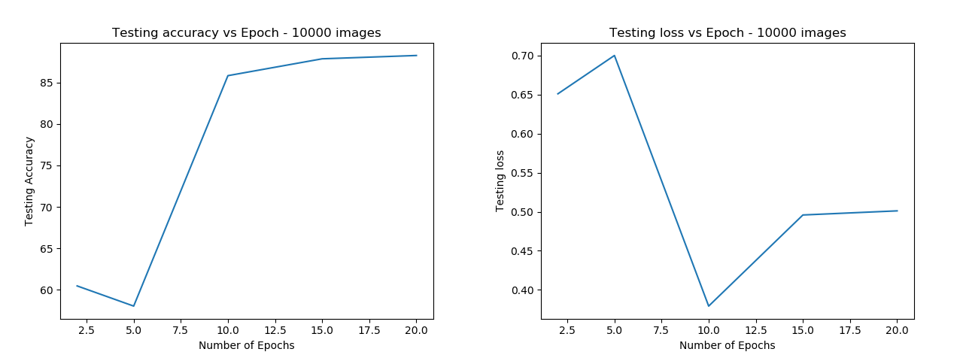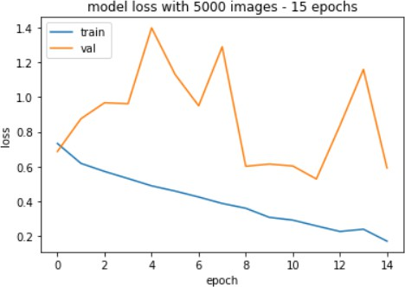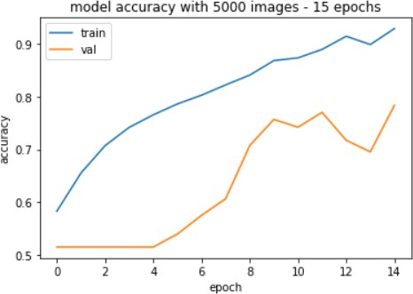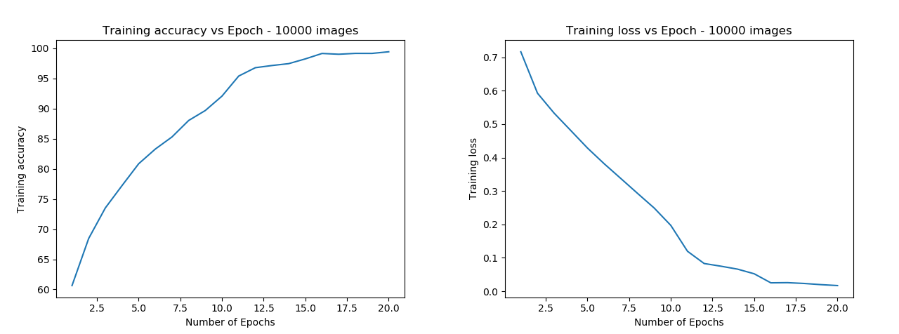

**Figure 4: Results for 10,000 images**

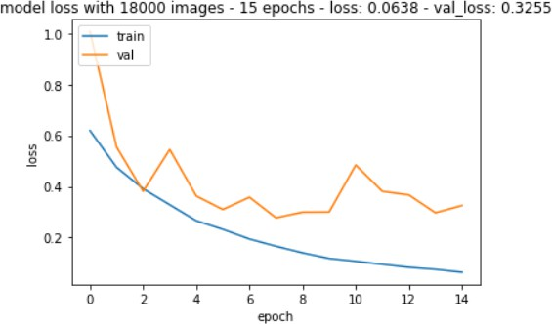 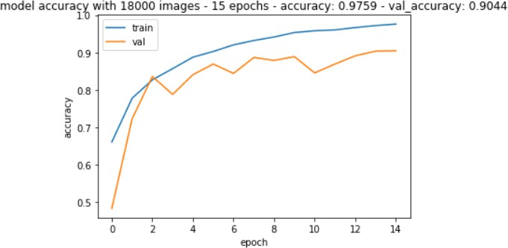

**Figure 5: Results for 18,000 images**

**Comparison with Existing Systems**

While traditional SVM or decision tree models achieve fair accuracy on basic datasets, CNNs outperform them significantly on large image datasets due to their ability to learn spatial hierarchies.

**Advantages and Limitations**

**Advantages:**

* Automated feature extraction
* High classification accuracy
* Scalable architecture

**Limitations:**

* Requires large labeled datasets
* Computationally expensive
* May overfit without proper regularization

**Applications**

* Medical Imaging (e.g., X-ray classification)
* Autonomous Vehicles
* Face Recognition
* Retail (e.g., product identification)
* Security Surveillance

**Future Work**

Future improvements include:

* Integrating transfer learning (e.g., VGG16, ResNet50)
* Optimizing for mobile deployment
* Using ensemble models
* Real-time prediction integration

**Conclusion**

This project demonstrated the implementation and effectiveness of CNNs for image classification. The model achieved high accuracy through carefully chosen architecture, regularization, and training techniques. The project can be extended to larger datasets and more complex classification tasks.

**References**

1. LeCun, Y., Bengio, Y., & Hinton, G. (2015). Deep learning. Nature.
2. Chollet, F. (2017). Deep Learning with Python. Manning Publications.
3. Project Repository: https://github.com/anubhavparas/image-classification-using-cnn *(You should remove hyperlink styling for formatting)*